**Introduction**

The COVID-19 pandemic and the Russia-Ukraine conflict represent two of the most significant global events in recent history, each creating ripples across economies worldwide. While the pandemic disrupted supply chains and labor markets, the geopolitical tensions exacerbated these challenges, particularly through volatility in energy markets and inflationary pressures. Understanding how such events shape macroeconomic dynamics is essential for crafting informed policy responses.

This paper investigates the economic repercussions of the Russia-Ukraine war and the COVID-19 pandemic on key U.S. economic indicators, employing a Vector Autoregression with Exogenous Variables (VARX) model. By analyzing monthly data from 2013 to 2024, sourced from reliable platforms such as the Bureau of Labor Statistics and Federal Reserve Economic Data, the study evaluates inflation rates, crude oil prices, unemployment, and financial market indices. The model results demonstrate correlations between geopolitical shocks and macroeconomic variables, highlighting the vulnerabilities in economic systems during crises. This research provides a nuanced understanding of the transmission mechanisms of geopolitical and pandemic-induced shocks, offering insights for policymakers to strengthen economic resilience in times of global uncertainty.

The significance of this research lies in its policy implications. Identifying the economic sectors most affected by global shocks enables policymakers to implement targeted interventions, enhancing the economy's resilience. By exploring these interdependencies, this paper contributes to the broader discourse on economic stability in an era of heightened uncertainty.

**Literature Review:**

Research by the International Monetary Fund (IMF) highlights significant disruptions to global supply chains due to the combined effects of the COVID-19 pandemic and the Russia-Ukraine conflict. The report notes that U.S. inflation surged to 9.1% in mid-2022, driven by soaring energy and food prices, exacerbated by geopolitical tensions disrupting resource exports.

Studies conducted by the Congressional Research Service emphasize the influence of pandemic-induced fiscal policies and the Russia-Ukraine war on the U.S. trade deficit. U.S. imports from conflict-affected regions decreased by 22% in 2022, reflecting the broader challenges of maintaining trade balances amidst rising defense expenditures and disrupted trade networks.

Ukraine conflict has compounded these issues, particularly in energy-dependent industries, further highlighting the structural fragilities exposed by these global crises.

**References:**

* International Monetary Fund. (2023). *Global Economic Impact of Supply Chain Disruptions*. IMF Economic Outlook. https://www.imf.org/en/Publications/WEO
* Congressional Research Service. (2023). *U.S. Trade Patterns Amid Global Geopolitical Shifts*. CRS Report IF11789.<https://crsreports.congress.gov>
* World Bank. (2023). *Energy Price Shocks and Their Impact on Global Economies*. World Development Report.<https://www.worldbank.org>
* Deloitte. (2022). *Tracking Consumer Sentiment: Economic Uncertainty in the U.S.*. Deloitte Insights.<https://www.deloitte.com>
* Federal Reserve Bank of New York. (2023). *U.S. Monetary Policy in Response to Geopolitical and Pandemic Challenges*. Economic Policy Review.<https://www.newyorkfed.org>

**Data and Methodology**

**Data Ingestion**

This study utilizes a consolidated dataset spanning January 2013 to August 2024, drawn from reputable sources such as the Bureau of Labor Statistics (BLS), Federal Reserve Economic Data (FRED), U.S. Energy Information Administration (EIA), and Yahoo Finance. The dataset encompasses 15 key economic variables, including Consumer Price Index (CPI), Crude Oil Prices, Producer Price Index (PPI), Unemployment Rate, Federal Funds Rate, S&P 500 Index, Volatility Index (VIX), USD/Ruble Exchange Rate, and other macroeconomic indicators essential for understanding the dynamics of the U.S. economy. These variables were selected to provide a comprehensive view of economic trends and to evaluate the impact of the COVID-19 pandemic and the Russia-Ukraine conflict.

**Data Preprocessing**

To prepare the data for analysis, preprocessing steps included temporal alignment and aggregation. Daily data was converted into monthly averages to reduce noise and ensure consistency across variables. Two event flags were constructed to capture the temporal scope of the crises: the COVID-19 flag, spanning from January 2020 to May 2023, and the Russia-Ukraine conflict flag, beginning in February 2022. These binary indicators were incorporated into the dataset to model the exogenous shocks from these events. After merging all variables, the dataset comprised 140 monthly observations across 15 economic indicators, representing a robust framework for the econometric analysis.**Exploratory Data Analaysis**

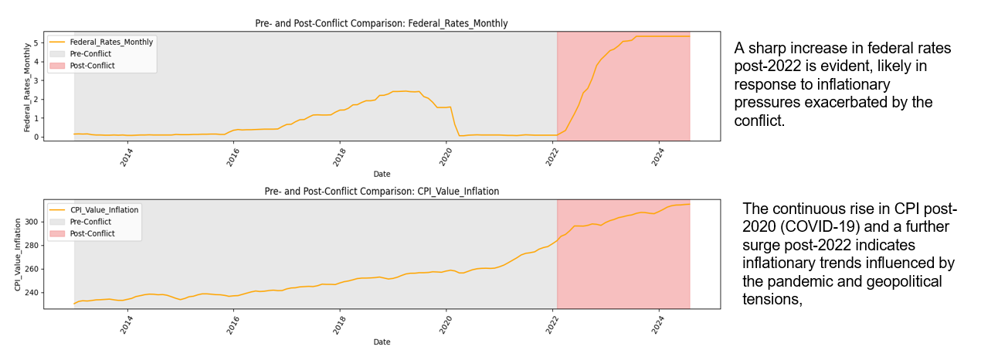

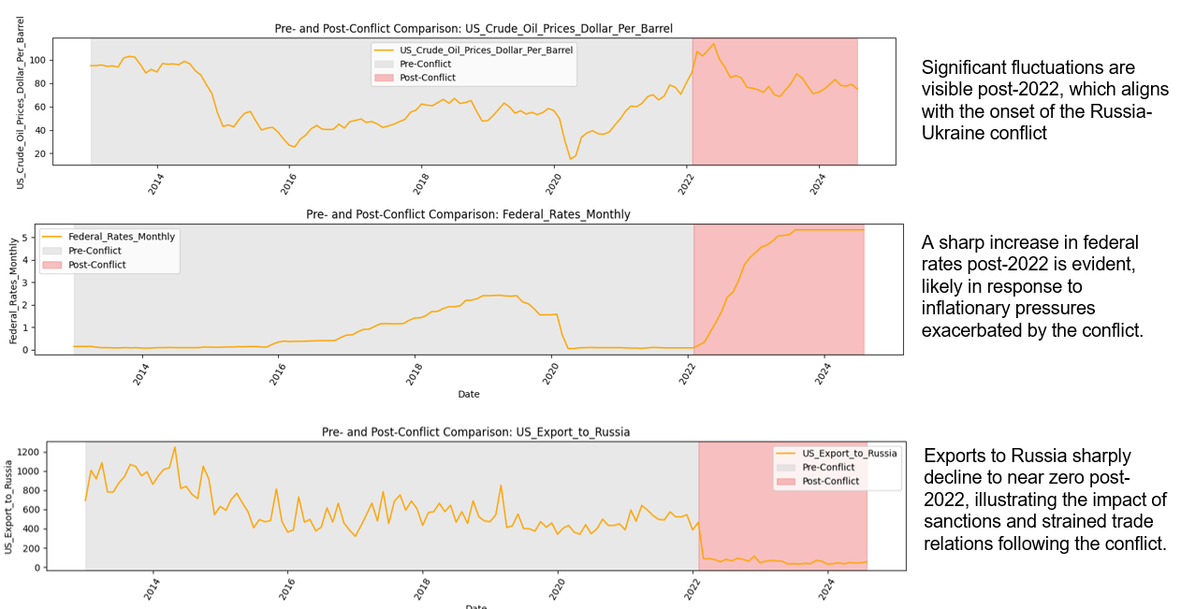

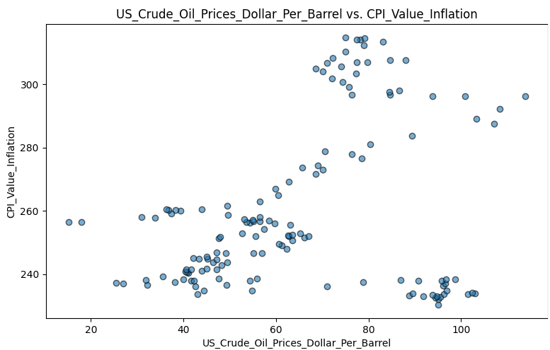 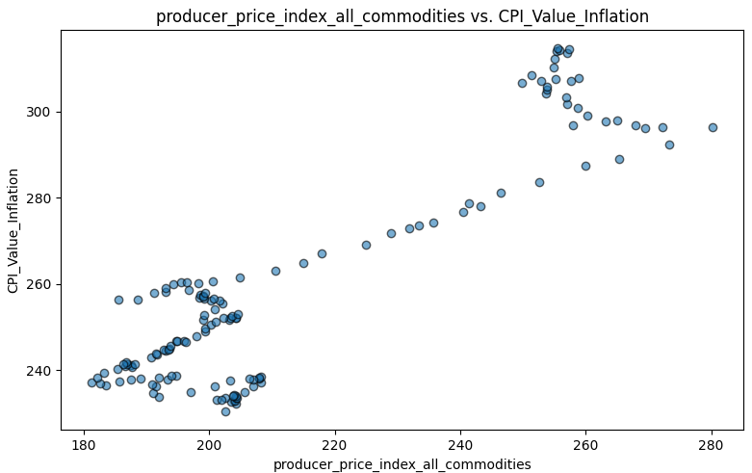

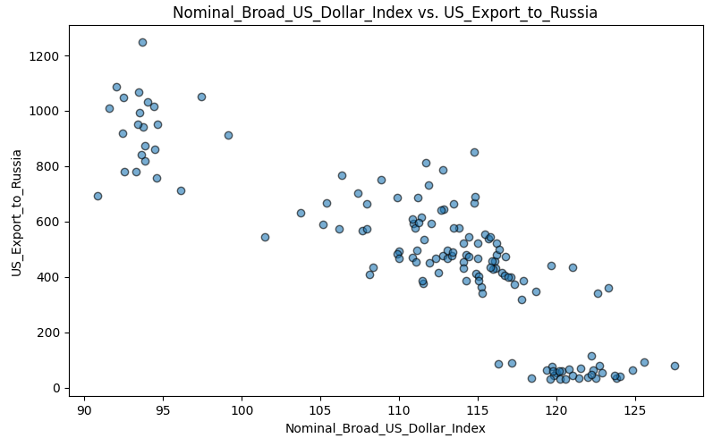 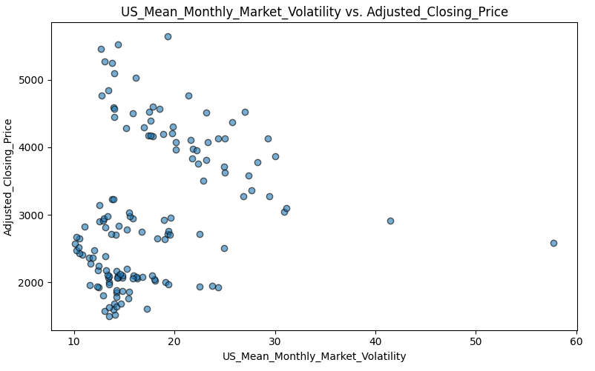

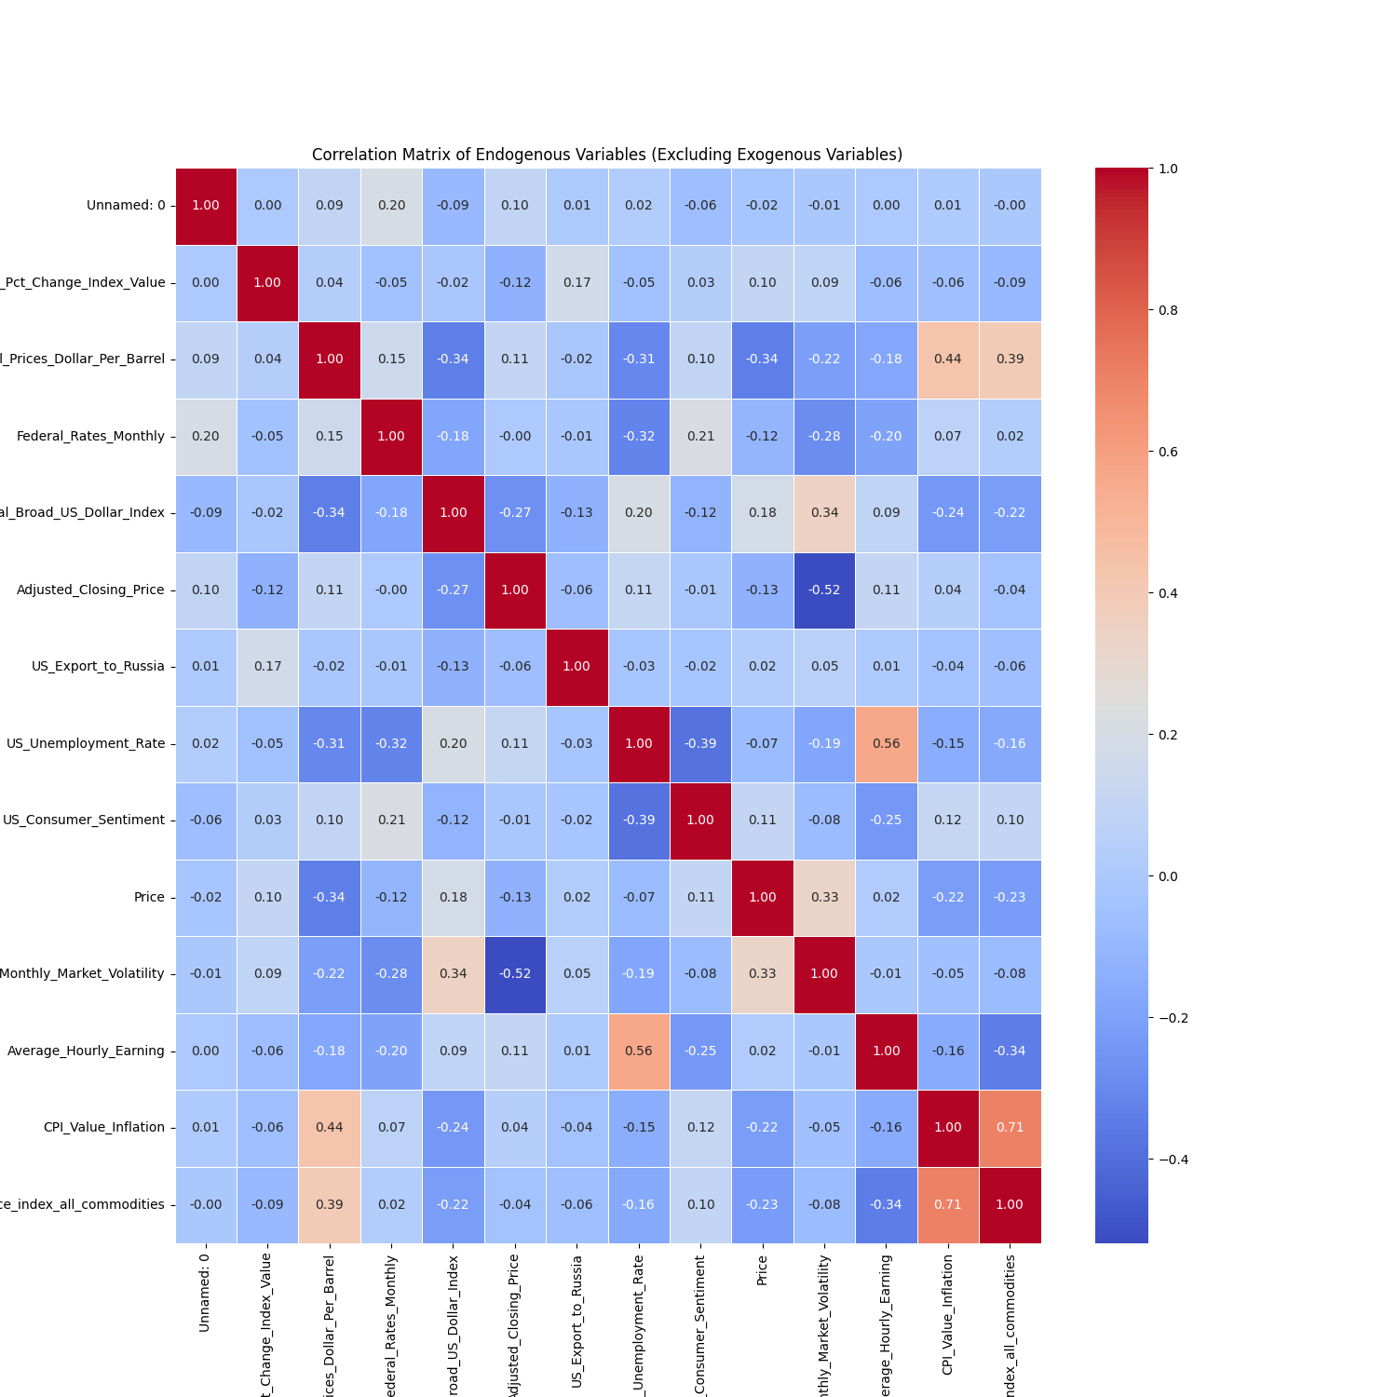

**Data Stationarity**

Stationarity is essential for Vector Autoregression with Exogenous Variables (VARX) modeling to ensure reliable and interpretable results. To assess stationarity, the Augmented Dickey-Fuller (ADF) and Kwiatkowski-Phillips-Schmidt-Shin (KPSS) tests were applied. These tests respectively check for unit roots (non-stationarity) and stationarity through trend analysis. The dataset consisted of variables that exhibited varying levels of stationarity, requiring a combination of approaches to address non-stationarity effectively.

Three variables—Trade Volume Percentage Change Index Value, U.S. Unemployment Rate, and U.S. Mean Monthly Market Volatility—were inherently stationary. No transformations were necessary for these variables as both the ADF and KPSS tests confirmed their stationarity.

For variables that showed trends or seasonality, transformations were performed. First-order differencing was applied to eliminate non-stationarity for most variables. Specifically, variables such as Average Hourly Earnings, Federal Rates Monthly, CPI Value Inflation, Nominal Broad U.S. Dollar Index, and Producer Price Index (PPI) achieved stationarity after first-order differencing. The results of the ADF and KPSS tests on these transformed variables confirmed the absence of trends or unit roots, making them suitable for VARX modeling.

However, some variables required second-order differencing to achieve stationarity, particularly those with persistent trends or structural shifts. These included Average Hourly Earnings, CPI Value Inflation, and Producer Price Index (PPI). The transformations ensured that the dataset adhered to the stationarity requirements for econometric analysis.

To further validate the results, rolling mean and standard deviation plots were generated. These visualizations confirmed that the data series exhibited constant mean and variance post-transformation. This rigorous approach to stationarity testing and transformation ensures that the dataset is robust and compliant with the assumptions of VARX modeling.

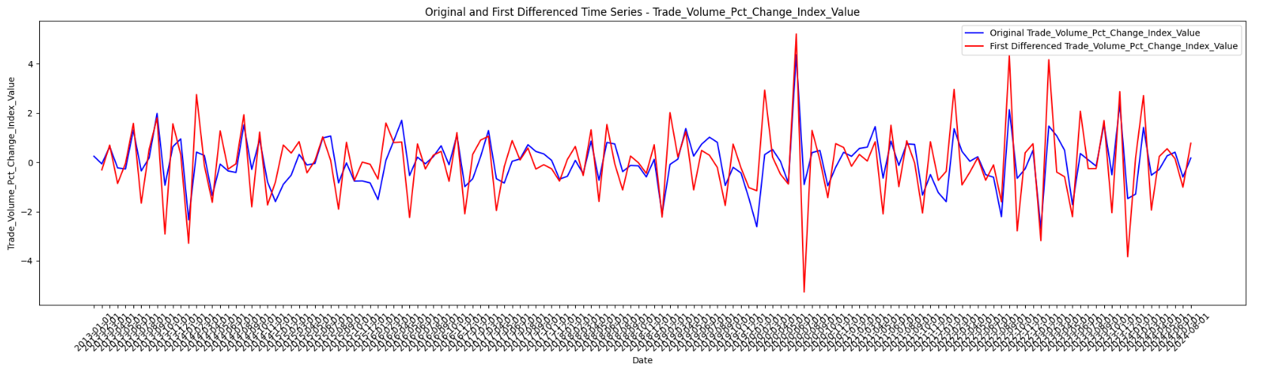

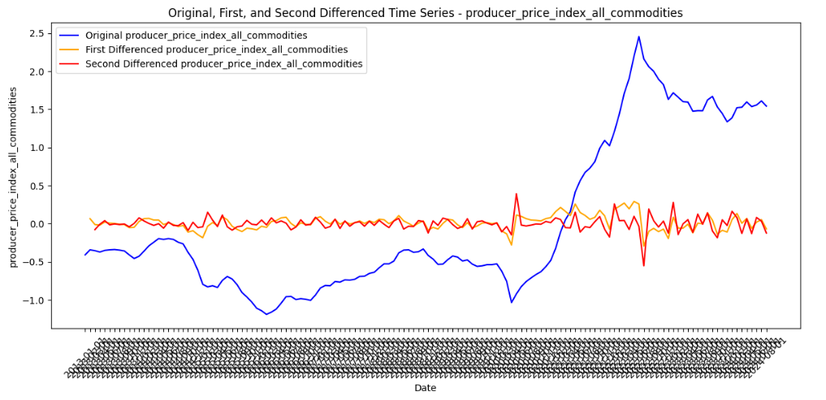

**Modelling Methodology:**

A Vector Autoregression with Exogenous Variables (VARX) model is an econometric tool used to analyze the dynamic relationships among multiple interdependent time series while incorporating the influence of external factors or events. Unlike simple regression models, which assume unidirectional relationships between dependent and independent variables, a VARX model captures bidirectional interactions and feedback mechanisms among endogenous variables. Additionally, the inclusion of exogenous variables allows the model to account for external shocks, such as geopolitical conflicts or global pandemics, that can influence the system without being affected by it.

The VARX model was chosen for this project because it provides a robust framework to analyze how key U.S. economic indicators respond dynamically to external shocks like the COVID-19 pandemic and the Russia-Ukraine conflict. By explicitly incorporating event flags as exogenous variables, the model enables us to quantify the impact of these disruptions on inflation, unemployment, and financial market indices. Unlike univariate models like ARIMA, which only handle single time series, the VARX model accommodates the multivariate nature of our data, capturing the complex interdependencies among economic indicators while considering external influences.

To guide the analysis, we formulated the following hypotheses:

1. Russia-Ukraine Conflict Hypothesis:
   * Null Hypothesis (H₀): The Russia-Ukraine conflict, as represented by the exogenous variable Russia_Ukraine_Date_Flag, has no significant impact on key U.S. economic indicators.
   * Alternative Hypothesis (H₁): The Russia-Ukraine conflict has a significant impact on key U.S. economic indicators.
2. COVID-19 Pandemic Hypothesis:
   * Null Hypothesis (H₀): The COVID-19 pandemic, represented by the exogenous variable Covid_Flag, has no additional impact on U.S. economic indicators, independent of the Russia-Ukraine conflict.
   * Alternative Hypothesis (H₁): The COVID-19 pandemic has a significant additional impact on U.S. economic indicators, independent of the Russia-Ukraine conflict.

These hypotheses allow us to evaluate whether the modeled external events have a measurable and distinct influence on macroeconomic dynamics.

Determining the optimal lag order is critical for capturing the temporal relationships among variables while avoiding overfitting. Using the Bayesian Information Criterion (BIC), the optimal lag order for the VAR model was determined to be 1. The BIC, favored for its conservative approach to model selection, suggests that a simpler model with a single lag balances fit and complexity. The consistency between the BIC and HQIC criteria reinforces this choice, confirming that a lag order of 1 is sufficient to capture the relationships between the variables in our dataset.

Incorporating the exogenous variables ‘Russia_Ukraine_Date_Flag’ and ‘Covid_Flag’ transformed the VAR model into a VARX model, enabling an evaluation of their influence on key economic indicators. The model utilized stationary data for endogenous variables while including the event flags as exogenous variables. Python's statsmodels library was employed to estimate the parameters of the VARX model using the VARMAX implementation, with the optimal lag order set to 1 based on BIC. An iterative optimization method ensured reliable parameter estimates. This setup facilitates the analysis of causal and dynamic relationships between economic indicators and external shocks, offering valuable insights for policymakers and researchers.

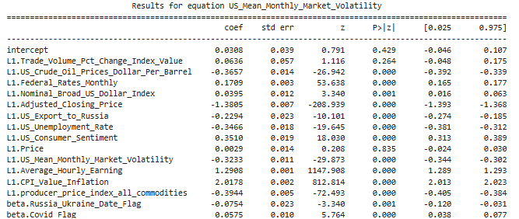

**Model Equations for Variable that were Affected by the Events (According to the Model)**

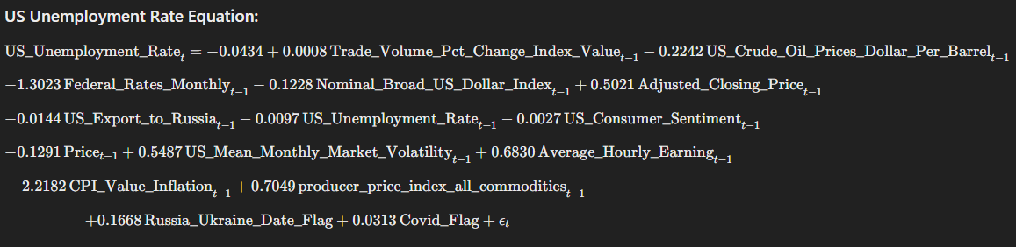

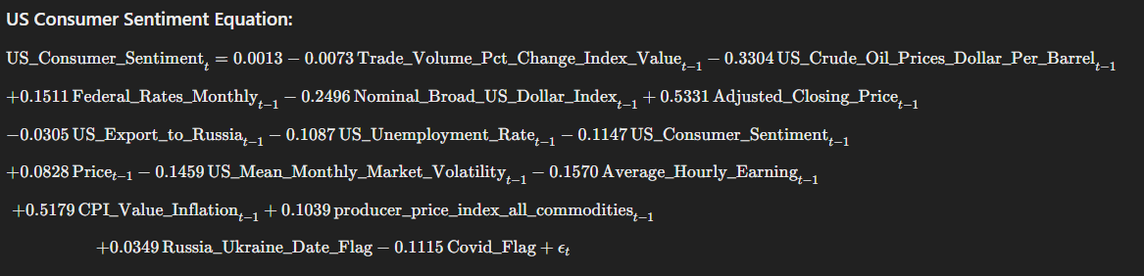

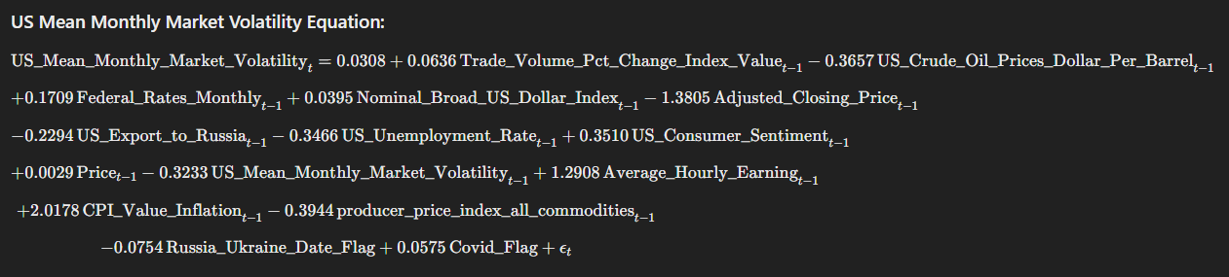

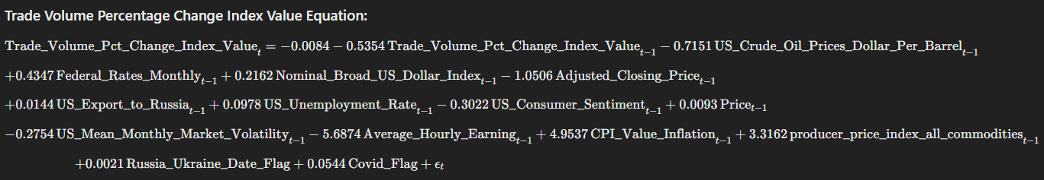

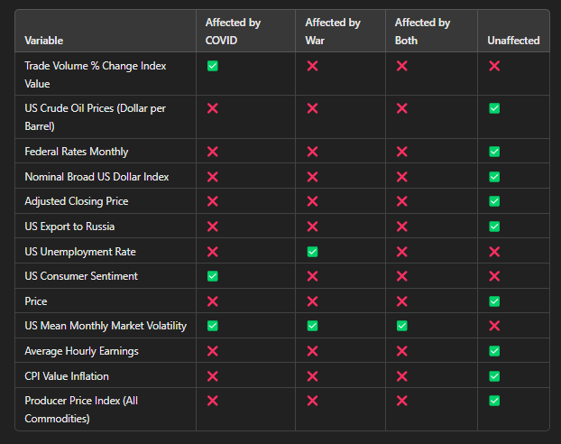**Results and Conclusions:**

The VARX model provides valuable insights into the dynamic impacts of the COVID-19 pandemic and the Russia-Ukraine conflict on key U.S. economic indicators. By comparing the model results with real-world observations, we categorize the findings into three groups: correctly captured, partially captured, and not captured variables.

*Correctly Captured Variables:*

The model effectively captures the dynamics of **Nominal Broad U.S. Dollar Index**, **Adjusted Closing Price**, and **U.S. Mean Monthly Market Volatility**, accurately reflecting their resilience during the studied crises. For example, the model highlights the persistent stability of the dollar index and its indirect links to global crises. Similarly, the market volatility results align with the real-world impact of COVID-19, which caused sharp fluctuations in financial markets. These results demonstrate the model's ability to correctly quantify the influence of shocks on relatively stable economic indicators.

*Partially Captured Variables*

Variables such as **Trade Volume Percentage Change Index Value**, **Federal Rates Monthly**, **U.S. Unemployment Rate**, **U.S. Consumer Sentiment**, and **Producer Price Index (PPI)** fall into this category. The model identifies some, but not all, of the expected impacts:

* **Trade Volume**: The model captures autocorrelation and volatility effects during COVID-19 but underestimates the disruptions caused by the Russia-Ukraine conflict.
* **Federal Rates and PPI**: While the model captures their links to inflation and broader economic conditions, it misses the external shock-driven fluctuations caused by the crises.
* **U.S. Unemployment Rate**: The model highlights the war's influence on labor markets but overlooks the COVID-19-driven unemployment surge.
* **Consumer Sentiment**: The model captures the interplay between sentiment, inflation, and market variables but underrepresents the war's psychological impact.

These results show the model’s strength in identifying internal dynamics but reveal its limitations in fully capturing external shock impacts.

*Not Captured Variables*

Several variables, including **U.S. Exports to Russia**, **CPI Value Inflation**, and **Average Hourly Earnings**, are not well represented in the model.

* **U.S. Exports to Russia**: Despite sanctions and export restrictions following the Russia-Ukraine conflict, the model underestimates the direct and immediate decline in trade.
* **CPI Value Inflation**: The model fails to capture the sharp inflation spikes caused by pandemic-induced supply chain disruptions and war-driven energy price increases.
* **Average Hourly Earnings**: Wage dynamics influenced by COVID-19-related labor shortages and changes in labor demand are missed.

The VARX model performs well in capturing stable and interconnected indicators but struggles with volatile or multi-crisis-driven variables. While its strength lies in identifying persistence and internal linkages, future models could benefit from incorporating nonlinear relationships and higher-frequency data to better capture external shocks. These findings emphasize the importance of enhancing econometric methodologies for complex crisis analyses.

**Future Work Scope:**

This study analyzed the dynamic effects of the COVID-19 pandemic and the Russia-Ukraine conflict on key U.S. economic indicators using a VARX model. While the results provided meaningful insights, several limitations and opportunities for further exploration emerged.

*Data Limitations*: The analysis was conducted using a relatively short time series dataset of 140 monthly observations. This approach was chosen to avoid the volatility inherent in weekly data, ensuring smoother trends. However, the limited data points may have constrained the model's ability to generalize and fully capture long-term impacts. Expanding the dataset to include more historical data or higher-frequency observations could enhance the model's robustness and predictive capacity.

*Short-Term vs. Long-Term Impacts****:*** Our model used a lag value of 1, focusing primarily on short-term relationships between variables. While this approach effectively highlights immediate economic responses, it does not account for long-term ripple effects. Employing a higher lag model would allow for an analysis of extended temporal relationships, providing a more comprehensive understanding of how external shocks shape economic indicators over time.

*Event Flags and Variable Precision***:** The model relied on binary event flags for the COVID-19 pandemic and the Russia-Ukraine conflict to represent the presence or absence of these crises. While effective for capturing broad impacts, this approach does not consider the varying intensity of events within these periods. A more precise methodology would involve weighted flags, where key events receive higher weights to reflect their relative significance. Such an approach could better capture the nuanced effects of these crises on economic dynamics.

Post-Model Analysis**:** Our study lays the groundwork for more detailed post-model analyses that could strengthen the reliability and interpretability of the results. The following techniques were performed but not discussed in detail in this paper due to page restrictions:

* *Residual Analysis*: Evaluating residuals to ensure they follow a normal distribution with zero mean.
* *Histogram and QQ Plots:* Used to visually confirm residual normality.
* *Model Diagnostic Checks:* Tests like the Ljung-Box Test for autocorrelation, ACF and PACF plots
* *Granger Causality Test*: Test to assesses whether past values of one variable statistically improve the prediction of another, identifying potential directional relationships between time series.
* *ARCH Test:* Test for heteroscedasticity were conducted to validate model assumptions.
* *Historical Decomposition Analysis:* To disentangle the contributions of each shock to variable movements over time.
* *Counterfactual Analysis:* Investigating how economic indicators might have evolved in the absence of the events.
* *Sensitivity Analysis:* Assessing the robustness of the results under different model specifications and assumptions.